***File uploading from a pc to server:

Username: cisco

Password: cisco

If we want to connect a pc with server then we need to use this command(ftp server_ip). This is the first command for upload and read a file to or from server.

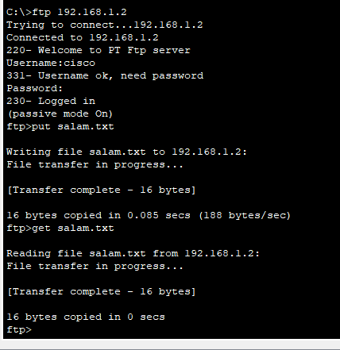

***Gateway setup using command line:

Router>en

Router(config)#config terminal

Router#interface gig0/0

Router(config-if)#ip address mask

Router(config-if)#no shut down

Static Routing command:

Ip route ip address mask next hop

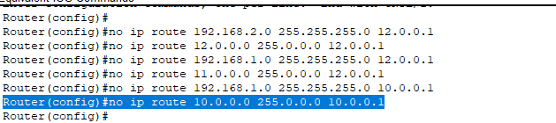

Default routing:

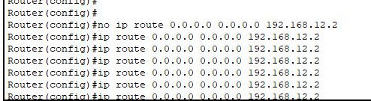

***DHCP:

i)Configuring DHCP server on router:

